Robot v1.31

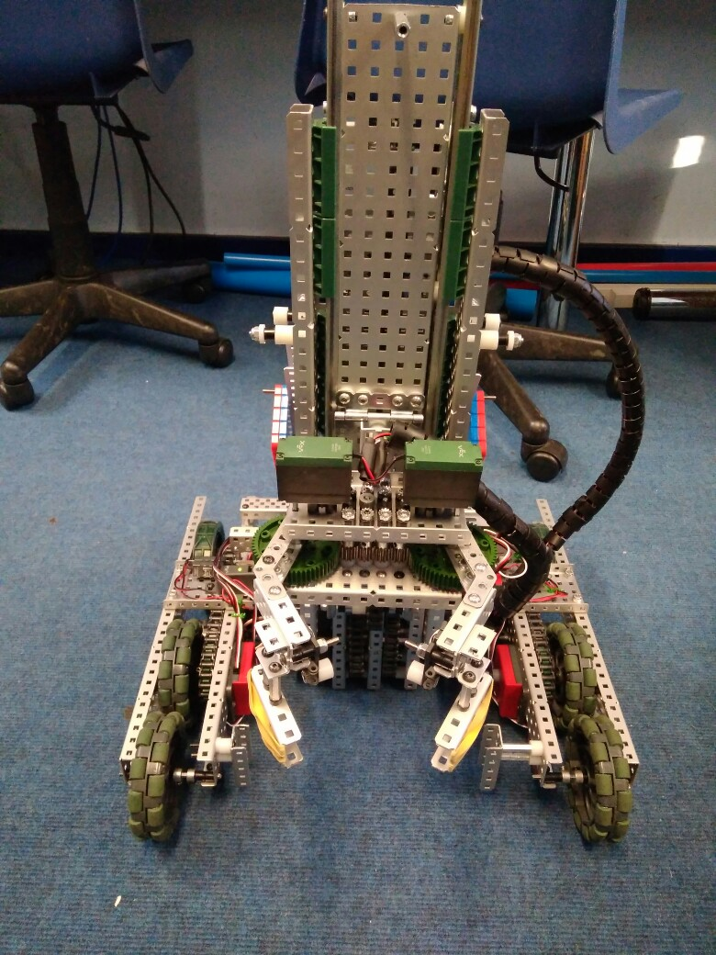

**Specification:**

* 6 Motor HS drive
* 2 drive chains
* 4 omni – 2 friction wheels
* Aluminium structure
* 4 motor lift
* 3 stage lift
* 2 motor flip down claw
* 5.5kg weight

**Dimensions:**

* 17.5” x 17.5” x 17.5” when not extended

Logged by Sam Poirier

15/09/2017 – 11:13

**Future Changes:**

* Program PID control
* Add limiter switches again

**Overview:**

There hasn’t been much visible progress over the last 20 days due to the fact that team has started school again and has not have much time available to spend working on vex. However, we did manage to get a few things fixed. We switched out the back omni-wheels for traction wheels to be assist the robot going over the bars. We also managed to fix the drive problem (as shown in problem log 3 on page #). The last thing we did was adjust the mogo (mobile goals) section of the claw to be better at picking up mogos by shortening it and by adding rubber bands for grip.

**Changes Made:**

* Fixed drive problem
* Moved over to pros for software development
* Replaced rear wheels with friction wheels
* Rebuilt claw